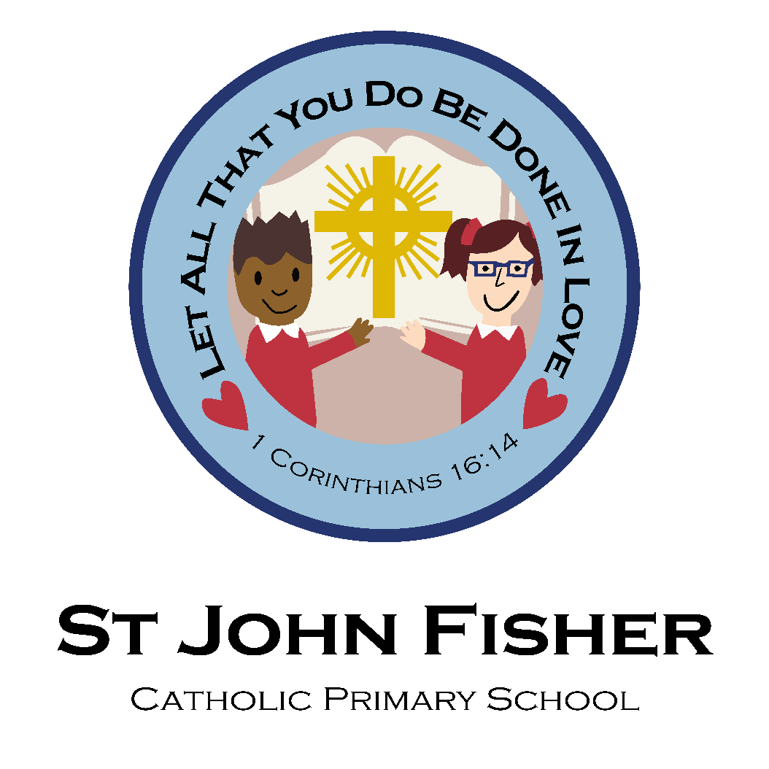

Prayer and Liturgy Policy
Date policy last reviewed:
Last updated: 05/02/2026
Signed by:
Paul Higgins | Headteacher | Date: | 05/02/2026
Ian Courtney | Chair of governors | Date: | 05/02/2026

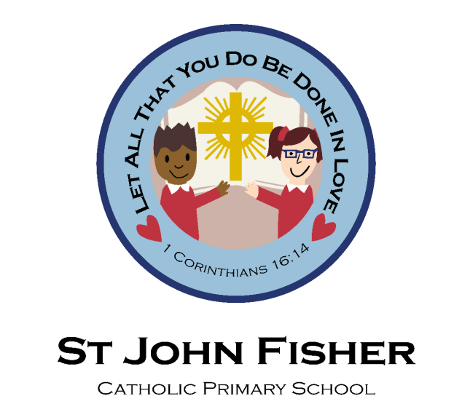
Prayer and Liturgy Policy
Mission Statement:
“Let all that you do be done in love”
RE lead: Aurnia McCarthy
Link Governors:
RE teaching and learning: Joyce Kamugisha
Prayer and Liturgy: Louise Butler

At St John Fisher, we believe that love should inspire every aspect of school life. We believe that love motivates our school community to show care and commitment as we strive to achieve the highest possible standards in all areas. A loving response to life enables pupils, parents, teachers, and governors to fulfil their vocation within our community.
Our school community takes its name and inspiration from St John Fisher, whose courage, integrity, and faithfulness to Christ guide our understanding of discipleship. His witness challenges us to live with truth, love, and commitment to our faith, even in the face of difficulty. Through prayer and liturgy, we seek to place Christ at the heart of daily life and to nurture a strong and living faith within our community.
Prayer and Liturgy provide regular and meaningful opportunities for pupils to develop their relationship with God, to grow spiritually, and to reflect on their vocation as children of God. Working in partnership with parents, who are the first educators of their children in faith, we aim to guide pupils along a pathway of holiness, supporting them to live out Gospel values and to respond generously to God’s call in their lives.
At St John Fisher School, Prayer and Liturgy is therefore a vital expression of our Catholic life and mission. It contributes significantly to the formation of the whole person—spiritually, morally, and socially—ensuring that the Catholic identity of the school is lived, celebrated, and witnessed in a way that is inclusive, prayerful, and faithful to the teachings of the Catholic Church.
The place of Collective Worship in our school
As a Catholic school, St John Fisher School bases its worship, ethos, and curriculum firmly on the teachings of Jesus Christ. Collective Worship within our school is more than a statutory requirement; it is an integral and distinctive element of daily school life and lies at the heart of our Catholic tradition and identity.
We are committed to ensuring that the liturgical life of the school is meaningful, prayerful, and engaging. Worship is planned to be creative and diverse, offering opportunities that both stimulate and challenge pupils spiritually, supporting their personal faith journey and spiritual development. Through these experiences, pupils are encouraged to reflect, pray, and grow in their relationship with God.
This policy supports the liturgical life of St John Fisher School by providing clear guidance for a range of acts of worship. These include individual and class prayer, Gospel Assemblies, and whole-school celebrations of the Mass, held either in school or within our parish churches—Blessed Dominic Barberi Church and Sacred Heart Church—in partnership with the parish community and the wider Church.
We recognise and value the rich cultural and religious diversity of the society in which we live. In line with Catholic Schools Inspectorate expectations, Collective Worship at St John Fisher School is planned to be inclusive and invitational, taking into account the religious and educational needs of all who participate, including:
- Those who are active members of the worshipping Church community
- Those for whom school may be their first or only experience of Christian worship
- Those from other Christian traditions, other faiths, or none
Through this inclusive approach, Collective Worship remains authentically Catholic while respecting the dignity, faith background, and spiritual journey of every individual within our school community.
Definitions
- Liturgy
The word liturgy literally means “the work of the people” and reflects the communal nature of worship within the Church. Liturgy is the official, public worship of the Catholic Church and expresses the faith lived and celebrated by the People of God. It includes the celebration of the Church’s seasons and feasts throughout the Liturgical Year, the structure of daily prayer through the Liturgy of the Hours, specific rites such as the Funeral Mass, and the celebration of the Sacraments.
Within a school context, liturgy refers to acts of worship that incorporate the rites, rituals, signs, and symbols of the Catholic Church, enabling pupils to experience and participate in the prayerful life of the Church in a meaningful and age-appropriate way.
- Prayer
Prayer is the means by which we encounter God and develop a relationship with Him. The Catechism of the Catholic Church describes prayer as “a vital and personal relationship with the living and true God.” One of the early Fathers of the Church, St John Damascene, defined prayer as “the raising of one’s mind and heart to God or the requesting of good things from God.”
In a Catholic school, prayer is central to daily life. It underpins all that we do and is an essential part of each school day, helping pupils to grow in faith, reflect on their lives, and develop a habit of turning to God in trust and thanksgiving.
- Collective Worship
Collective Worship is our loving response, in word and action, to God’s invitation to enter into a relationship with Him. This invitation is made possible through the saving work of Jesus Christ and sustained through the witness and guidance of the Holy Spirit.
Collective Worship takes place in a variety of settings within school life and is not limited to whole-school gatherings. It includes worship experienced in classrooms, small groups, and other school contexts, offering regular opportunities for prayer, reflection, and spiritual growth that are inclusive, invitational, and authentically Catholic.
- Mass
For Catholics, the Mass is the central act of worship and the heart of the Church’s life. At Mass, the Last Supper is remembered and made present. Through the power of the Holy Spirit, bread and wine become the Body and Blood of Jesus Christ. This belief, known as transubstantiation, is a defining element of Catholic faith and distinguishes Catholic teaching from that of many other Christian traditions.
The Eucharist is the source and summit of Christian life. As members of the Church, “we receive the Body of Christ and are increasingly being transformed into the Body of Christ.” Participation in Mass therefore plays a vital role in nurturing faith and strengthening the spiritual life of the school community.
Classroom Prayer and Liturgy
Classroom prayers are said:
- at the beginning of the school day
- at the end of the school day
- Lunchtime prayers
- After lunchtime prayer
- At the beginning of every religious education and prayer lesson
During other times of the liturgical year, other prayers might be said in accordance with our progression of prayer.
At least once a week, all children participate in prayer and liturgy as in Key Stages (EYFS and Key Stage 1, Lower Key Stage 2, Upper Key Stage 2). Children are organised into GAP Groups (Gathering and Praying) and are expected to plan, organise, deliver and evaluate prayer and liturgy sessions. Children use the to aid the delivery of their sessions and evaluate (appendix 2) to make improvements. Key Stage prayer and liturgy sessions are planned for in accordance with the Liturgical year or topical themes like school-specific celebrations (for example, our Classroom Saints) or a local, national or international event that is publicised.
Other
Children have the opportunity to lead our school community or prayer and times of reflection during Advent in the form of nativity plays (Nursery, Reception and Key Stage 1) and Carol Services (Key Stage 2) and during Lent in the form of the Stations of the Cross (Whole School).
Planning Liturgy
When planning any services, we use the gather, listen, respond and mission model. This model reflects the four parts of the Mass. When planning prayer and liturgy, special attention must be made to the liturgical season of the church. As children grow in age and confidence, they can take a more active role in the planning and delivery of the liturgy.
Gather, Listen, Respond, Mission
Prayer and Liturgy in our school may follow the model or variation of the pattern detailed below:
• Gather - how we come together, the setting, the environment (quiet/ reflective music, lighted candles, statues, sign of the cross, focus and examination of conscience etc.).
• Listen - a reading from the Scriptures (or another suitable source), breaking the word, time to reflect on this and prayers to fit into the theme.
• Respond - a ritual movement that everyone can join in with that fits with the theme (gestures such as shaking hands, holding hands, lighting a candle, prayers, responses to prayers, etc.).
• Mission- the sending out from the celebration, giving the children something to hold onto from the experience of the liturgy that they can take into their daily lives.
Early Years | - Suggest the focus  - Select an appropriate colour cloth linked to the theme or appropriate for the liturgical year.  - Place candles and artefacts in the centre.  - Respond with personal ideas and/or prayers.
Years 1&2 | As above but with:  - With adult support, help to plan aspects of prayer and liturgy  - Write or say simple prayers.  - Choose songs that fit the theme of worship (with guidance).  - Choose artefacts.  - Lead the start (Sign of the Cross) and reinforce the mission
Years 3&4 | As above but with:  - Planning the four components that flow within the same theme.  - Choose songs  - Choose Scripture (with guidance)  - Link the theme and Mission to our Catholic Social Teaching both around our school and in the community
Years 5&6 | As above but with:  - Choose Scripture independently  - Link the theme and mission message to Catholic Social Teaching

Whole School/ Key Phase Collective Worship
- Monday – Head teacher Gospel Assembly
- Tuesday – Deputy Headteacher- Virtues Assembly
- Wednesday- Prayer and Liturgy
- Thursday- Mission of the Week
- Friday - We meet to celebrate all the positive things that have taken place in school during the week. Children are recognised for their hard work, as well as the skills and talents that they have shared with us. We also celebrate children's achievements outside of school. All members of our school community are welcome to join us.

At St John Fisher School, we believe that creating the right atmosphere is essential in helping children to prepare for prayer and to experience a sense of peace, reverence, and tranquillity. A prayerful environment supports pupils in entering with stillness, reflection, and encounter with God. This may include:
- the use of candles
- appropriate lighting
- reflective or prayerful music
- visual prompts or religious artefacts
Each class is provided with a prayer and liturgy box containing a range of resources, including Scripture, coloured liturgical cloths, candles, religious artefacts, and other prompts. These resources enable pupils to plan and lead prayer and liturgical experiences within their classes and small groups, supporting their active participation and developing leadership in worship.
We expect pupils to develop a secure understanding of formal prayers as they progress through the school. By the end of each phase, children should be familiar with the majority of diocesan-expected prayers, as well as the prayers and responses used in the celebration of Mass (see Appendix 3). This supports their growing confidence in participating fully and reverently in the liturgical life of the Church.
Alongside formal prayer, we actively encourage both pupils and staff to offer spontaneous prayer. This nurtures a personal and authentic relationship with God and supports pupils in developing their own voice in prayer, deepening their spiritual encounter and understanding of prayer as a lived and meaningful part of daily life.
Monitoring and Evaluation
The provision of prayer and liturgy at St John Fisher School is monitored and evaluated on a termly basis to ensure it remains meaningful, inclusive, and faithful to the Catholic life and mission of the school. This process supports continuous improvement and ensures that provision meets the spiritual and developmental needs of all pupils.
The Liturgy Team plays a key role in the monitoring and evaluation process and works closely with senior leaders to review the quality and consistency of practice across the school. Monitoring activities include:
- Reviewing class prayer and liturgy folders to ensure that all groups are using the agreed school prayer and liturgy template
- Observing classroom-based prayer and liturgy sessions to evaluate pupil participation, reverence, and leadership
- Reviewing evidence of prayer and liturgy to ensure clear links to the Liturgical Year and the teachings of the Church
- Monitoring classroom and communal prayer areas to ensure they accurately and appropriately reflect the Liturgical Year
- Observing Gospel Assemblies and evaluating pupils’ understanding of the key message and its impact across the school week
- Checking that pupils’ knowledge and participation in prayer are in line with expectations for their phase
The Headteacher ensures that the required level of monitoring takes place each term and that findings inform future planning and development. Outcomes from monitoring and evaluation are reported to governors, who review a sample of evidence and provide appropriate challenge and support as part of their responsibility for overseeing the Catholic life of the school.
Role of the Coordinator
The co-ordinator will be responsible for:-
- Formulating a written policy;
- Ensuring there is a development plan for collective worship;
- Ensuring that collective worship is appropriate to the age, aptitudes and family backgrounds of pupils;
- Ensuring that collective worship takes account of the religious and educational needs of all who share in it and is rooted in the Catholic teachings;
- Organising themes for worship;
- Assisting the governors and head teacher in carrying out their legal responsibilities with regard to collective worship. Communication
This policy will be communicated to:
- All members of the school community;
- Parish priests
- New members of staff and will form part of their induction;
- New parents, to promote positive attitudes towards collective worship.

Legal Requirements
Collective worship is a legal daily requirement which is distinct from curriculum time. For Catholic schools this requirement is made explicit within the Trust Deed of the Archdiocese of Birmingham which states:
“Religious worship is to be in accordance with the rites, practices, discipline and liturgical norms of the Catholic Church. At all times the school is to serve as a witness to the Catholic Faith in Our Lord Jesus Christ.”
Parents have a legal right to withdraw their child from all or any part of Collective Worship. The CES has provided guidance about this. Policy Monitoring and Review This policy is monitored by the Leadership Team and is evaluated and reviewed by the whole school staff and governors every two years. The Foundation Governors, in particular, will play a most important role.

Traditional Prayers of The Church
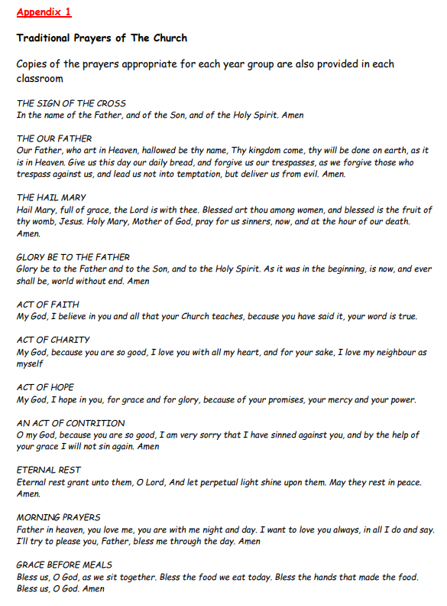
Copies of the prayers appropriate for each year group are also provided in each classroom

Agreed and reviewed by:
Date agreed: February 2026
Date for next review: February 2027

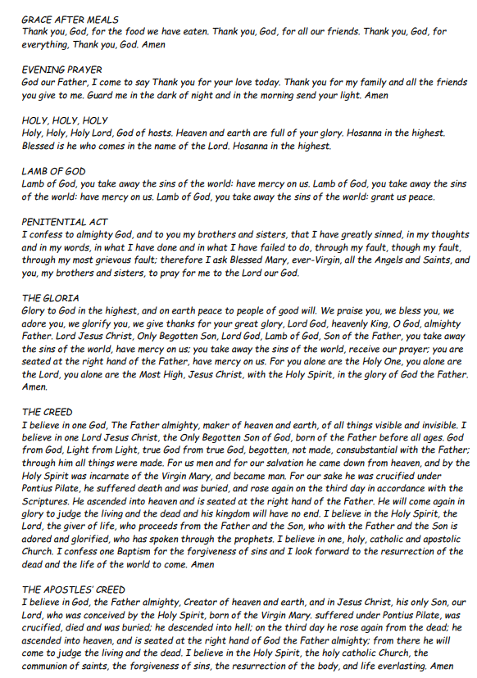

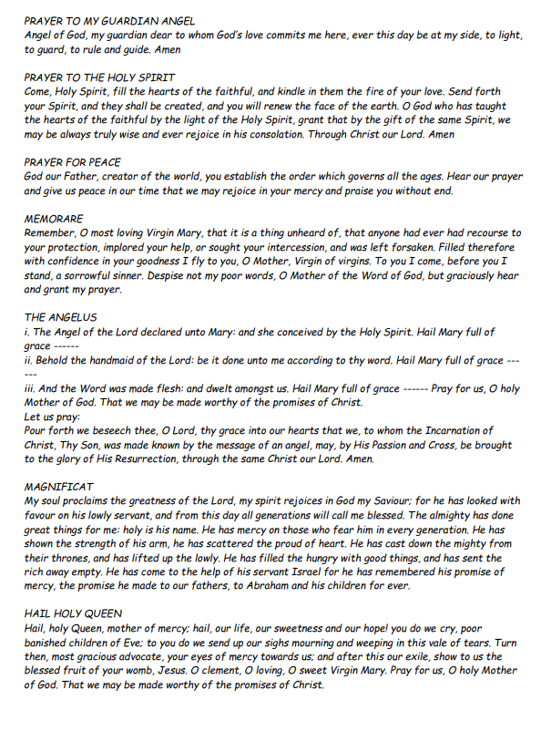

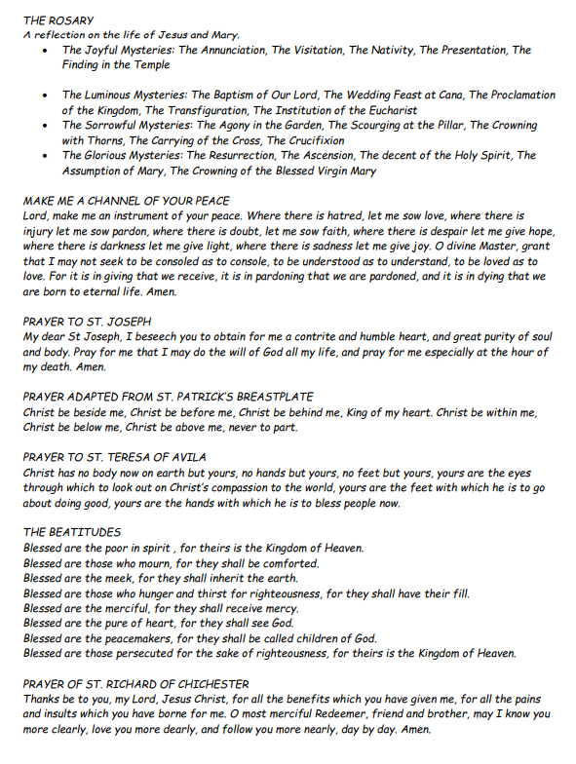

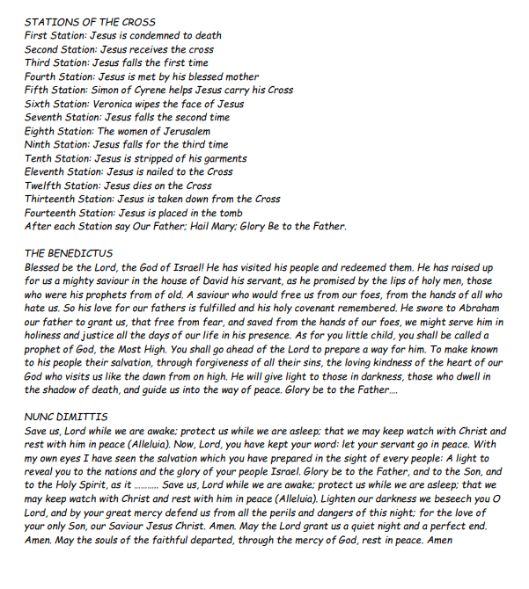

Agreed and reviewed by: Ian Courtney and Paul Higgins
Date agreed: February 2026
Date for next review: February 2027

