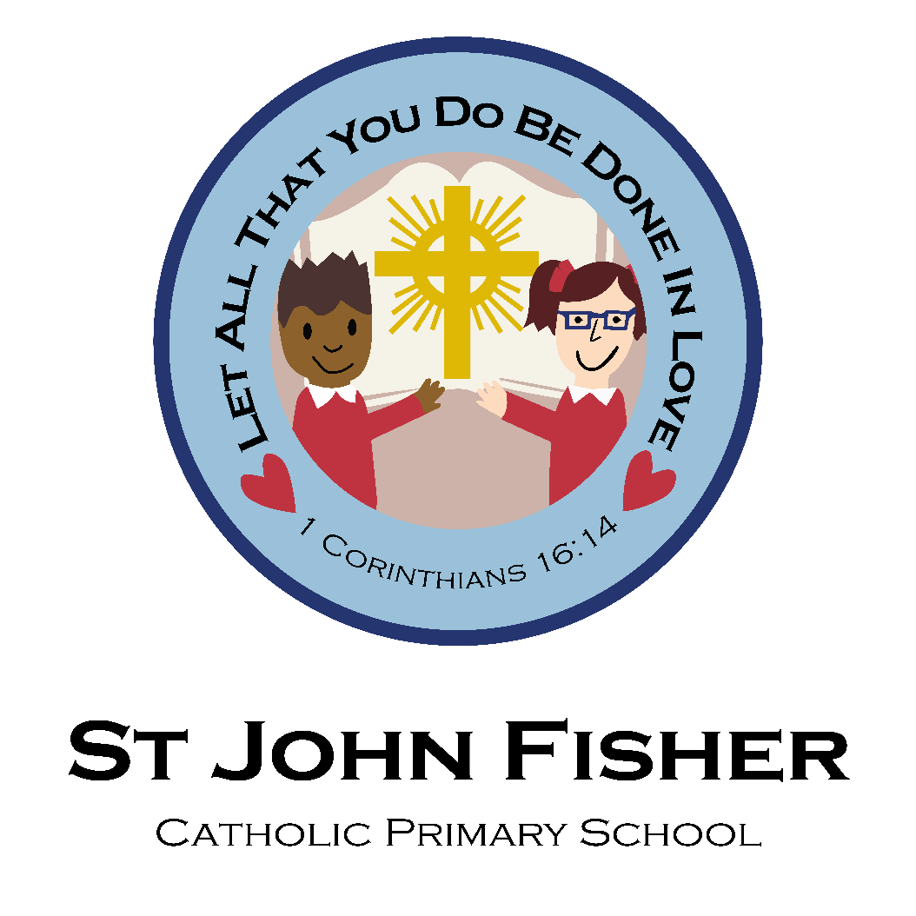

RE Teaching and Learning Policy
Date policy last reviewed:
Last updated: 17/07/2025
Signed by:
Paul Higgins | Headteacher | Date: | 17/07/2025
Ian Courtney | Chair of governors | Date: | 17/07/2025

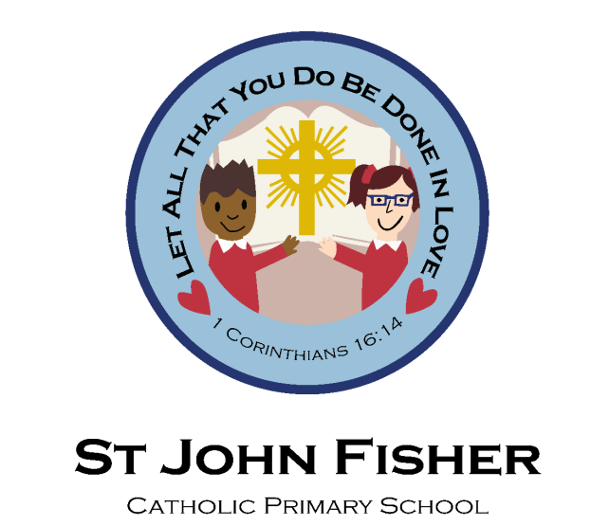
Religious Education Policy
Mission Statement:
“Let all that you do be done in love”
RE lead: Aurnia McCarthy
Link Governors:
RE teaching and learning: Joyce Kamugisha
Prayer and Liturgy: Louise Butler

Aims of Religious Education
At St John Fisher, we aim to fulfil our Mission Statement through the delivery of the curriculum and through the delivery of the virtues we share, and which permeate through all areas of school life.
Religious Education for us is not solely about developing each child’s religious knowledge. It is concerned with providing opportunities and experiences through which each child can grow and develop their faith and spirituality. It is also concerned with providing a moral code, based on the meanings of Christ. Furthermore, it is concerned with providing opportunities whereby each child can experience expressions of our Catholic culture and heritage.
The pre-school experiences of our pupils means that for some children, RE will be received as catechesis, deepening, and enhancing their personal faith, but for others, it will be evangelisation, the first time that they will have been presented with the main truths of living faith.
These aims demand that Religious Education comes before the core curriculum subjects. Indeed, these aims are only achieved through membership of the community. Here at St John Fisher, it is the partnership between school, home, and our Parishes which provides the full range of opportunities through which religious experience, faith and knowledge can be developed.
How we meet our stated aims
At St John Fisher, Religious Education lies at the heart of the curriculum and is central to the spiritual, moral, cultural, and intellectual development of our pupils. In line with the guidance of the Catholic Education Service and the Diocese of Birmingham, to achieve these aims, RE is presented through the following strands:
a) The Religious Programme of Study including multi-cultural education
b) Religious Practice
c) Sacramental Preparation
d) Pastoral care, behaviour and discipline
e) Links with other Curriculum areas
Learning and Growing as the People of God

“Learning and Growing as the People of God” is the model curriculum strategy published by the Archdiocese of Birmingham, in response to the Catechism, the Curriculum Directory and as a continuation of the Curriculum Mapping, which our school follows. Teachers use the strategy and the Long-Term Plan to create short term plans which are linked to a focus strand each year.

Planning Religious Education
Each class teacher has an RE file to help them plan for Religious Education over a four-year cycle. The Long-Term plan contains the Programme of Study for each year group. The Medium-Term plan contains the Units to be studied from the Archdiocesan Strategy. The Weekly plan shows aspects of the Units covered from the Archdiocese Scheme of Work. Class teachers also include an element of teaching focussed upon prayer each week.
Assessment of Religious Education
Assessment of individual pupils in RE is the responsibility of the class teacher. Teachers report to parents via consultations in the Autumn and Spring Terms, as well as by a written report at the end of the school year. Formative assessment is ongoing through the teachers’ marking and through observing children when completing tasks/ activities. A schedule of assessment is compiled each year to enable teachers to assess three times a year. This assessment is completed using a traffic light system as detailed below:
- Green – Attainment above the expected standard for their Year group
- Yellow – Attainment at the expected standard for their Year group
- Red – Attainment below the expected standard for their Year group

Assessment sheets are given to the RE Subject Leader at the end of each unit. An important element of assessment is in the evaluations at the end of each unit. These provide valuable information for present teachers, future class teachers, the Subject Leader, aids the monitoring of the Curriculum, the ordering of resources and the development of INSET. The RE Subject Leader will monitor and moderate the work of three children in each class at the end of each of the assessed units. The class teacher will also record and monitor the work of three children in their class for the whole year. This will be kept to enable progress to be seen over a longer period of time. This also provides evidence in monitoring of the skills which are being taught.
How we teach Religious Education
Religious Education is delivered by class teachers to all children in school in their class year groups. A wide range of teaching methods is used to make RE lessons engaging, inclusive, and reflective. These include:
  - Whole-class teaching and group work
  - Scripture reflection and discussion
  - Use of religious art, music, and drama
  - Opportunities for prayer and worship
  - Cross-curricular links, particularly with literacy, history, and PSHE
Teaching encourages theological enquiry, critical thinking, and personal reflection, enabling pupils to explore, question, and articulate their faith.
Multi-Cultural Education
Throughout the academic year, every year group will be introduced to other religious festivals and cultures in the Archdiocese’s scheme. During one week in the Summer Term, all children participate in our Multi-Faith Week. During this week various activities are arranged, and visitors are invited to come in, to teach the children about their culture and religion through art, music, dance etc. Every year, the school also hold an International Day which involves every child being invited to bring in food and wear clothes from their culture.
Equal Opportunities
At St John Fisher school, all children have equal access to the Religious Education curriculum, regardless of their gender, religion, culture or Special Educational Needs. Wherever possible, full participation in all aspects of RE is expected and encouraged. However, parents have the right to withdraw their children from these. With regards to the Sacraments, all children in KS2 are involved in preparatory lessons and are invited to the relevant Parish celebrations. Those who are not able to receive Communion may receive a blessing. Those not able to receive absolution are able to have a few private moments with the Priest and can receive a blessing during Reconciliation services.
Prayer Life of the School
It is through the observance of and participation in acts of prayer, worship and celebration of the Liturgy that the child can have the opportunity to express their faith and to develop their relationship with God. School, for many of our pupils, is their first sustained experience of the Catholic tradition. We provide a range of opportunities where the faith can be practised.
• Formal prayer: morning, mealtimes, afternoon and end of the day
• Class prayer time
• Collective Prayer - in class, Liturgical Year focus, Saints and Celebration assemblies
• Celebration of Mass: whole school at the beginning and end of the School Year and on Holy Days of Obligation; classes attending Mass in school and in Church at various times during the year.
• Celebration of Marian Mass
• Observance of Feasts, Saints’ days and the Church calendar
• Hymn Practice and choir practice
• Faith Days in conjunction with other PFMAC schools
• Retreats based on sacramental preparation

Prayer Focus
Each classroom has an area that is a prayer focus. It reflects the current Liturgical Season and has a range of religious objects displayed upon it. It should have an age-appropriate Bible or Bible story displayed as well as the prayers that the particular year group should know by heart. Each class appoints Prayer Leaders and Faith Ambassadors who help to maintain the prayer area within their classroom.
Faith Leaders
Faith Ambassadors will be 2 children who have put themselves forward to support the strong Catholic ethos of the school. During the year, Faith Leaders will; hold meetings to decide charities to fundraise for, priorities for RE and Prayer and Liturgy, observe acts of worship and monitor prayer areas.
Saints and Feast Days
As well as learning about significant people in the History of the People of God, we also ensure that the children learn about the lives of saints throughout their time at St John Fisher school. In 2020, we renamed our classes after significant saints, to enable children to learn about their lives, to celebrate their Feast days and to use this knowledge to encourage us to live our lives following in their example of devotion and trust in God. On a class’s feast day, children will attend one of our local parishes.
Our class saints are:
• St Nicholas – Nursery
• St Terese of Lisieux - Reception
• St Francis of Assisi - Year 1
• St Michael the Archangel – Year 2
• St Brigid of Ireland– Year 3
• St Josephine Bakhita – Year 4
• St Bernadette of Lourdes – Year 5
• St Vincent de Paul – Year 6

Sacramental Preparation
Preparation for the Sacraments of Reconciliation and the Eucharist currently take place in Year 3 on a yearly basis. Opportunities to receive the Sacrament of Reconciliation are during the Advent Season in December, and in the Lent Season in March/April. These come in the form of a Penitential Service led by our Parish and local Priests. The children are prepared for this Sacrament in school by Mrs McCarthy who has taken training from the Birmingham Diocese. Preparation for the Sacrament of Confirmation takes place in Year 6. This is taught by the Parish Priest according to the Archdiocese Strategy and supported by the class teacher through the RE Curriculum. The Parish Priests, Miss McCarthy and Mrs McCarthy send information about the sacramental preparation before the programme begins. Confirmation takes place on a yearly basis. Attendance at retreats also forms part of the preparation for the Sacraments.
Involvement with Parents and the Parish Community
The parents and Parish are positively encouraged to involve themselves with the religious life of our school. They are invited to all school Masses via the school newsletter, the Parish newsletter and emails from the school office.
There are two parents’ evenings per year when the children’s progress can be discussed. The children’s annual reports also detail their progress. The school encourages the children to attend Mass on Sundays where they can participate in the activities led by the Children’s Liturgy groups. All Masses that the children attend have Parish members present. Members of the Parish are invited to have refreshments with the Headteacher and Parish Priest at intervals throughout the year.
Some of the children are altar servers and assist at both school and Parish Masses. The school and Parish are linked by several fund-raising events that take place during the year, e.g. CAFOD, Mission Together and Father Hudson Care.
Links with other Curriculum areas including Information and Communication Technology
Religious Education has close links with other Curriculum areas. Firstly, many of the skills that are developed in RE, are skills which are transferrable to other subjects. For example, research gathering and referencing skills are used in all academic areas. Likewise, the varied writing skills developed in Literacy can be practised and developed within the RE Curriculum. Secondly, as an academic subject, RE has strong links with both History and Geography. Finally, ICT can be used for word processing and as a tool for research.
Health and Safety
Class teachers should follow current procedures when crossing roads to the Church (Health and Safety Policy and Risk Assessments). Any matches kept in classrooms must be kept securely out of children’s reach. The teacher is responsible for ensuring that candles are lit and extinguished safely.

Link Governor
Beginning in January 2024, Mrs Butler and Mrs Kamugisha became our link governors. Mrs Butler will support the RE lead in overseeing Prayer and Liturgy and Mrs Kamugisha will support the RE lead in overseeing RE Teaching and Learning. Both governors will support the oversight of Catholic Life. Their roles will involve visiting the school and meeting with the RE Subject Leader to understand how the aims of RE are being met, to discuss future projects and to discuss how actions from Inspections are achieved.
Agreed and reviewed by: Ian Courtney and Paul Higgins
Date agreed: February 2026
Date for next review: February 2027

