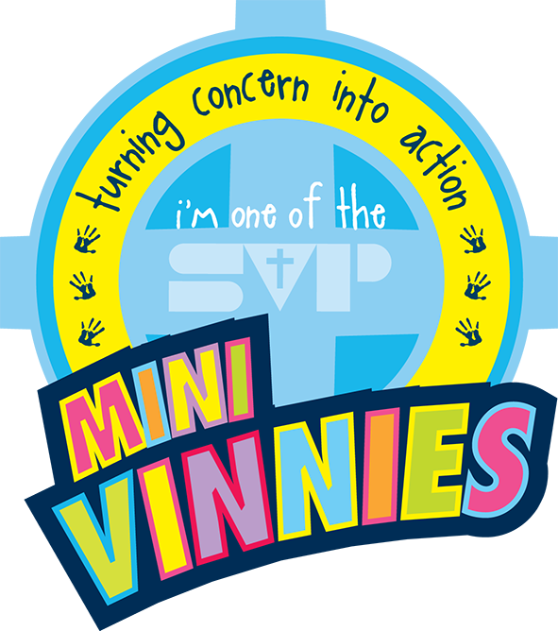
MINI VINNIES BAKE SALE!

On the 24th May, we invite you to meet us (Selasi, Mason MR, Amber, Eve, and Georgette: The fundraising team) outside the office at 3:10pm.

CASH ONLY!
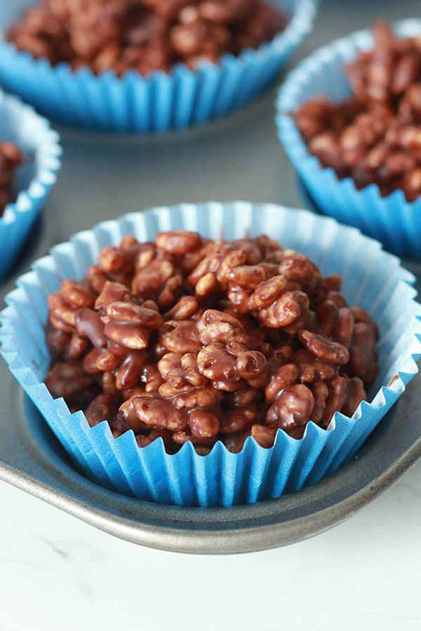

Cupcakes, doughnuts, cakes, Rice Krispie treats and more!
See you there.

